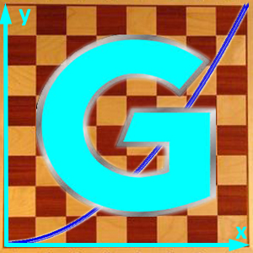
INVITATION

I invite you to the "Kick Off Meeting" of the Erasmus + project:

Math-GAMES - Games And Mathematics in Education for adultS
Compendiums, Guidelines and Courses for Numeracy Learning Methods Based on Games

Each partner hast o send at least 1 person, who is the partner’s coordinator and is speaking English. More persons are welcome.

Program

Date: Friday, 23rd of October to Sunday, 25th of October 2015

Place: Volkshochschule Schrobenhausen

Hotel: Hotel Post, Schrobenhausen, http://www.griesers-hotel-post.de/

Airport: Munich Airport (München), Munich Main Station (München Hauptbahnhof)

Aims of the meeting
- meet and learn about the partners, observe German Public Adult Education system,
- brainstorm preserving and developing quality of the new project,
- explaining the administration of the project,
- develop a common workplan and a common timeline for the project “Math-GAMES”.

Timetable (subject to modification)

Fr 23.10.2015 Arrival day

We bring you by private car or taxi from the airport to the hotel.

Please see the attached table of arriving and tell me, if something should be changed.

19:00: Get-together, whoever is already there, in Restaurant “Post” near by the Hotel.

Sat 24.10.2015 Working day

Meeting at 09:30 in front of the hotel, a short visit around the town of Schrobenhausen

10:00 Kick Off Meeting in the Volkshochschule Schrobenhausen

10:00 – 10:30 Each partner introduces himself in a short presentation (3 Minutes). If you use Power Point, we can put the presentation into our website as well.

10:30 – 12:00 Information about the Math-GAMES-Project by Roland (please take a printed version of the application with you, or you have it in the laptop), presentation, discussion, decisions

12:00 – 13:30 Lunch in a nearby restaurant

13:30 – 15:00 Information about the Erasmus+ project-rules, administration, forms (e.g. I need to have the IBAN and BIC from each project partner, because all the money has to be transferred via bank account. Contracts. Ways of communication.

15:00 – 15:30 Coffee break

15:30 – 17:30 Work on the projects content: presentation of examples, discussion, timeline, …

Each country must report by 2 or 3 games that it has selected provisional and may be learned by the basic knowledge in mathematics.

Managing risks and problems, discussion, evaluation of the day

19:00 Final Dinner

Sun 25.10.2015 Departure day

We will bring you to the city of Munich or to the Munich airport. Please tell us your wishes.

Sightseeing in Munich

Mon 26.10.2015 Second possible departure day

The contract is finally signed and I have been a member during the kick-off-meeting of all German Projects in Bonn. I received a lot of hints to do such a big project under the new rules of Erasmus+.
Now is up to us, to fill it with life.
The website www.math-games.eu and the logo above are just a draft and provisional. I hope you will help with ideas and designing.

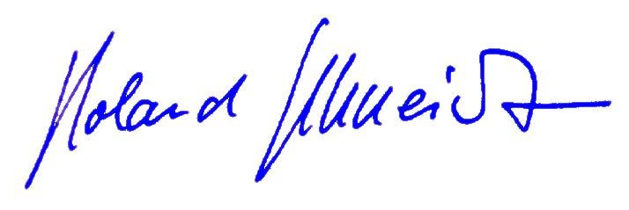
Best regards
Roland Schneidt, Volkshochschule Schrobenhausen
roland.schneidt@web.de 0049-173-4133492

